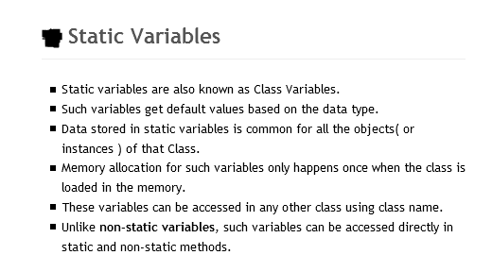

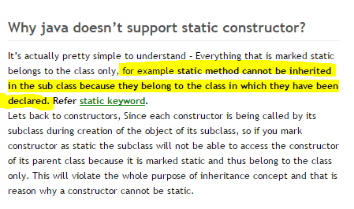

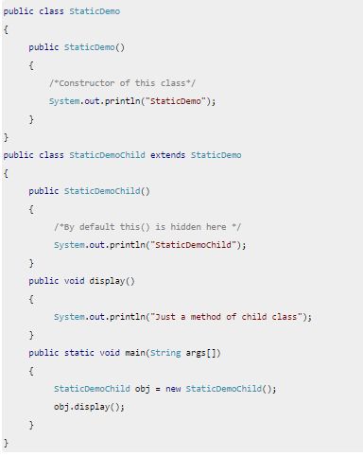

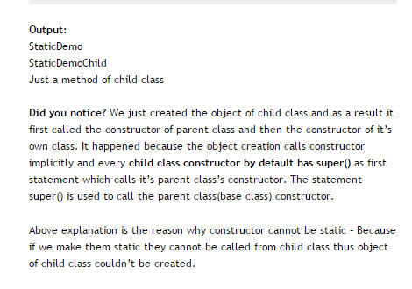

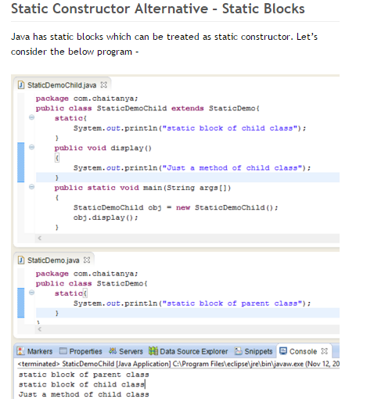

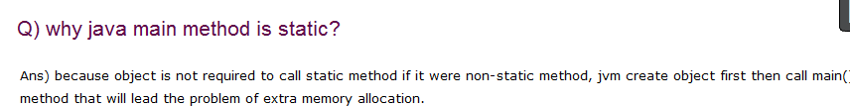

Static features: Static variable is used to store the data that is common to the entire class. It is a class variable because it is bound to class not to object. Static variables are allocated memory at class loading time. Class load time when the object of a class is created.

Static variables, Static Initialization Block and Static Methods – these all are static components or static members of a class. These static members are stored inside the Class Memory. To access static members, you need not to create objects. Directly you can access them with class name.

Static Initialization Block is used to initialize only static variables. It is a block without a name. It contains set of statements enclosed within { }. The syntax of SIB looks like this,

